**Assessing Citizen Feedback on Government Policies Using Python**

**Abstract**

Effective governance hinges on understanding and responding to citizen needs. In today's digital age, online platforms offer innovative avenues for collecting and analyzing public feedback on government policies. This project presents the development of a web application designed to assess citizen feedback on government policies, enabling policymakers to make informed decisions that resonate with the public. Leveraging the power of web technologies, the application fosters open communication and participation, bridging the gap between the government and its constituents.

The mini college project, "Assessing Citizen Feedback on Government Policies," leverages a comprehensive technology stack comprising HTML, CSS for the frontend, coupled with Python and Flask for the backend. This interdisciplinary approach facilitates the creation of an interactive platform aimed at collecting, analyzing, and presenting valuable feedback from citizens regarding government policies. The project not only addresses the technological challenges of web development but also delves into the realms of civic engagement and governance.

**Introduction**

Governments grapple with the challenge of crafting policies that cater to the diverse needs and aspirations of their citizens. Traditionally, feedback was gathered through limited channels like public hearings, town halls, and surveys. However, these methods often suffer from low participation rates, limited reach, and potential biases. The surge in internet usage has opened doors for new approaches to citizen engagement. Interactive web applications provide a dynamic platform for collecting and analyzing public opinion, offering valuable insights into policy effectiveness and areas of concern.

In an era where citizen participation is crucial for effective governance, harnessing technology to gather and analyze feedback becomes imperative. The project aims to bridge the gap between citizens and policymakers by providing an accessible and user-friendly platform for expressing opinions on government policies. By combining frontend technologies (HTML, CSS) for an intuitive user interface and backend technologies (Python with Flask) for data processing, the project endeavors to enhance civic engagement.

**Existing System**

Traditionally, citizen feedback mechanisms rely on physical town hall meetings, surveys, or limited online forms. These methods often face challenges such as low participation rates, time constraints, and difficulties in aggregating and analyzing diverse responses. The existing system lacks a unified and efficient approach to collect comprehensive feedback, hindering the government's ability to make informed decisions that align with public sentiment.

In many countries, the existing systems for collecting feedback on government policies remain traditional and passive. Reliance on outdated methods like written submissions, phone calls, and physical attendance at meetings restricts participation and limits the scope of feedback. These methods are often time-consuming, resource-intensive, and prone to logistical bottlenecks. Furthermore, analyzing the accumulated data through manual means can be cumbersome and inefficient, hindering actionable insights for policymakers.

**Proposed System**

This project addresses these limitations by proposing a robust and user-friendly web application built with HTML, CSS for the front-end and Python with Flask for the back-end. The application streamlines the feedback process by offering an intuitive interface where citizens can easily register, access policy information, and submit their opinions. Interactive features like forums, discussion threads, and surveys allow for in-depth feedback and nuanced understanding of public sentiment.

The proposed system revolutionizes the process of collecting citizen feedback by offering a dynamic and accessible online platform. The front-end, developed using HTML, CSS, provides an engaging and responsive interface for users to navigate effortlessly. The back-end, powered by Python and Flask, ensures secure data handling, storage, and efficient processing of citizen feedback.

The system allows citizens to express their opinions on specific government policies through user-friendly forms and interactive features. Additionally, the platform incorporates data visualization tools to present the feedback in an understandable format for policymakers. This approach enhances the transparency and efficiency of the feedback collection process.

**Modules**

* Data Collection
* Data Storage
* Data Review

**Web Interface**

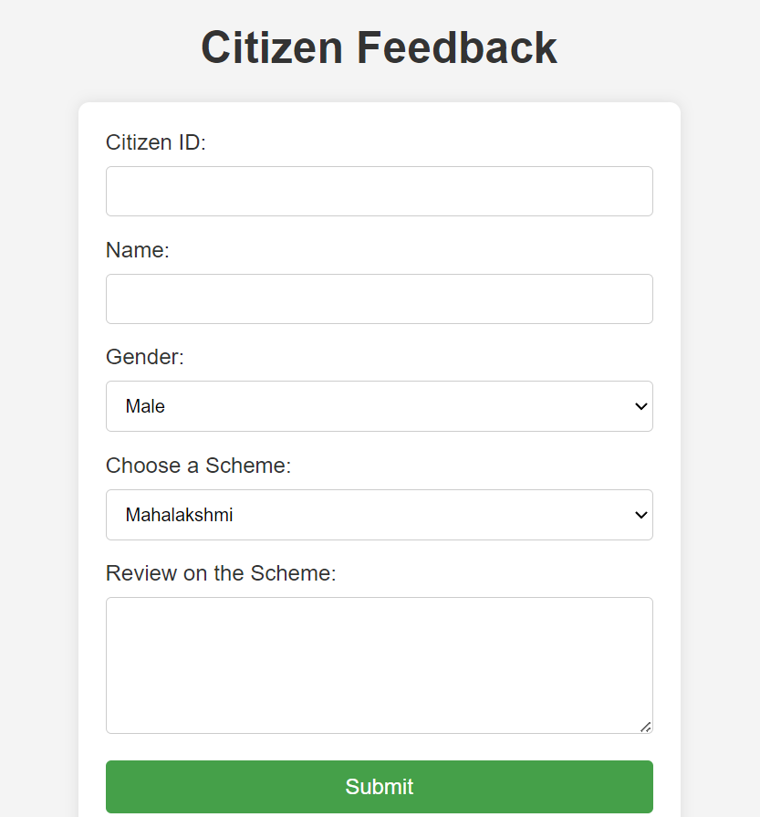

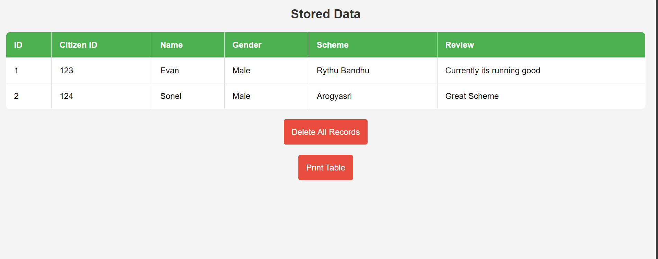

**Workflow**

**Web Interface**

**Data is Stored in Database**

**Data is Entered**

**The Data can be extracted into other forms.**

**The Data collected will be Visualized.**

**System Requirements**

The successful implementation of the project requires specific system components and configurations. On the frontend, modern web browsers supporting HTML5 and CSS3 are essential for optimal user experience. JavaScript, being a client-side scripting language, enhances interactivity. On the backend, Python 3.x with Flask is utilized for server-side logic, data processing, and communication with the frontend. Additionally, a relational database system, such as SQLite, is employed for efficient data storage and retrieval. The system is designed to be platform-independent, ensuring accessibility across diverse devices and operating systems.

**Requirements:**

* **Hardware Requirements:**

1. **System:** Intel I3 or AMD Ryzen 3
2. **Hard Disk:** 500 GB
3. **RAM:** >=4 GB

* **Software Requirements:**

1. **Operating System:** Windows
2. **Coding Language:** HTML, CSS, Python and Frameworks like Bootstrap and Flask

**Conclusion**

In conclusion, the project "Assessing Citizen Feedback on Government Policies" introduces an innovative approach to bridge the gap between citizens and government entities. The utilization of HTML, CSS ensures a user-friendly front-end experience, while Python with Flask handles the backend operations efficiently. This system has the potential to revolutionize the way governments gather and analyze citizen feedback, fostering a more participatory and transparent democratic process.

By embracing modern web technologies, this project contributes to the evolution of civic engagement, empowering citizens to actively participate in shaping government policies. The dynamic nature of the platform, coupled with the robust back-end architecture, positions it as a valuable tool for policymakers seeking genuine and diverse perspectives from the communities they serve.

This project marks a significant step towards enhancing citizen engagement and fostering informed government decision-making. By harnessing the power of web technologies, the proposed application bridges the gap between citizens and policymakers, empowering the public to have a meaningful voice in shaping their governance. The real-time feedback mechanism and transparent data visualization tools aim to cultivate a culture of open communication and responsive governance, ultimately leading to policies that better reflect the needs and aspirations of the people.